William Brand
- Mercury Malefactor
- Admin

- 8,884 posts
- Gender:Male
- Location:Logan, Utah
- Interests:My name is William Pace and I live and work as a graphic designer, illustrator and photographer in Northern Utah. I'm married to the lovely Tracy Pace and we have three children. In addition to all things art, I enjoy traveling and meeting new people from every walk of life. I've always been a fan of history, theology, and of course, Pyracy.
http://www.youtube.com/watch?v=PSkt-q-HihQ
(IP: 69.19.130.133) ·
Posted December 26, 2006 (edited) · Report post
I should like to discuss the widespread subject of parcels, bags, wallets, sacks and the like. For example, the haversack. When did it first come into use? Or the snapsack? Or the Townsman's Wallet? Frankly, I would like images and historical examples of the earliest use of every item used as luggage or purse, i.e., haversacks, hunting bags, wallets, pouches, ditty bags, snapsacks, etc.
Any help would be appreciated and period sources would be most appreciated.
Edited December 26, 2006 by William Red Wake

- Quote
- Edit

Fox
- Old Twillian
- Moderator

- 2,565 posts
- Gender:Male
- Location:Beautiful lush Devon, England
- Interests:Nautical history of the 16-18th centuries and living history based thereon.
Shooting pirates.
(IP: 86.136.122.176) · ·
Posted December 26, 2006 · Report post
Ah, one of the great under-discussed and under-researched subjects... Here's some for you.
The Haycock slop shop inventory of 1699 lists "hawking bags". I've not yet found a GAoP era depiction of a hawking bag, but modern hawking bags are pretty much identical to this 16thC example.

If we step just beyond the GAoP and into the 1730s we see examples of seamen with long snapsacks:
And into the 1740s:
However, snapsacks can be dated right back to the beginning of the GAoP (1690s) on landsmen:

The square shoulder bag can be seen at least as early as the 1670s

- Quote
- Edit
- Options

Capt. Sterling
- Sticky Fingers Sterling Needs a New Hat
- 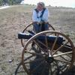
- Member

- 10,302 posts
- Gender:Pyrate Hunter
- Location:here
- Interests:Killing pirates, haven't met one yet worth keeping alive....
(IP: 76.1.130.73) · ·
Posted December 27, 2006 (edited) · Report post

&

All wallets from the V&A. The top leather wallet is is dated 1705.
The bottom leather wallet is from the late 17th century. The green wallet is from 1748.
Both leather wallets are believed to have been made in Turkey...
Edited December 27, 2006 by Capt. Sterling

- Quote
- Edit
- Options

Patrick Hand
- The sailor's sailor
- Moderator

- 6,100 posts
- Gender:Male
- Location:TH' Mountains of Central California
- Interests:I like wierdness... Klingon, Pyrate..... and even..... gasp.... Renn Faires...... (Baseball and tractor pulls I'd have to think about.... could be wierd or Not,,,,)
(IP: 209.78.171.157) · ·
Posted December 27, 2006 · Report post
Some thing to carry stuff in?
I'm not sure how period SeaBags are , nor Ditty bags.... but they are so dang simple to make that I can't beleave they just "sprang" from nothing... and then where "just "discovered" in the 1740's.....
A bag.... (depending on scale... Big= Seabag.. smaller= dittybag...) something to carry stuff in... OK.. maybe not the elaborate knotwork for the lanyard (heck in the early 1700's they couldn't tie knots...right?)
Dang.... I'm rattling....
I am going to write and post in plunder on how to make one(Sea bags , and Ditty bags....).... maybe not period, but they work....

- Quote
- Edit
- Options

Fox
- Old Twillian
- Moderator

- 2,565 posts
- Gender:Male
- Location:Beautiful lush Devon, England
- Interests:Nautical history of the 16-18th centuries and living history based thereon.
Shooting pirates.
(IP: 81.153.159.100) · ·
Posted December 27, 2006 · Report post
Pat, given the similarities in shape I suspect that the classic "ditty bag" evolved from the snapsack. In fact, I'm not convinced there is enough difference between the two to even think of them as different items.
The overtly decorative knotwork that we see on later seamen's artifacts seems to have been a fashion which developed in the later 18th century and reached its heyday in the 19th. We do know that knots were used generally for decorative purposes during the GAoP, just apparently not in such complex forms or to such an extent as later. I'm sure that having some sort of well-dressed end to the drawstrings of a bag, and a turks' head woggle to pull them closed would be quite likely. (Since we don't have a period bag to compare this is obviously just speculation based on the use of knots elsewhere in the period).

- Quote
- Edit
- Options

Capt. Bo of the WTF co.
- Scourge o' the 7 Seas
- Member

- 2,339 posts
- Gender:Male
- Location:Spanish Louisiana - on the river Osage
- Interests:Many and varied.
(IP: 4.244.75.164) · ·
Posted December 27, 2006 · Report post
I have a "market wallet" from Wilde's Weavery that I picked as a prize in a shoot last month. It is of linen and they do their own research and weaving. I gave it to my son, so as soon as he gets home from his mothers house, I will post photos of it. William, I suppose you are trying to decide what to hang from the tumpline that I will be sending out tomorrow?
I had visioned a snapsack from some of Kass's hemp canvas. I will be making one as well for myself.
Bo

- Quote
- Edit
- Options

William Brand
- Mercury Malefactor
- Admin

- 8,884 posts
- Gender:Male
- Location:Logan, Utah
- Interests:My name is William Pace and I live and work as a graphic designer, illustrator and photographer in Northern Utah. I'm married to the lovely Tracy Pace and we have three children. In addition to all things art, I enjoy traveling and meeting new people from every walk of life. I've always been a fan of history, theology, and of course, Pyracy.
http://www.youtube.com/watch?v=PSkt-q-HihQ
(IP: 69.19.130.133) · ·
Posted December 27, 2006 (edited) · Report post
Capt. Bo of the WTF co. said:
William, I suppose you are trying to decide what to hang from the tumpline that I will be sending out tomorrow?
I had visioned a snapsack from some of Kass's hemp canvas. I will be making one as well for myself.
Bo
Actually, my mother-in-law bought me a powder horn, so I will probably use the trumpline for that.
My main reason for the thread is actually covered by Gentleman of Fortune, for as he states, the subject is "one of the great under-discussed and under-researched subjects" and as such it needs to be researched. With the development of so many kits and camps for re-enactments, luggage and carrying bags must be brought under the scrutiny of the enthusiasts, so that we can instruct new pirates and ourselves on the best period items for kit.
Example, I am a big fan of leather hunting bags, but I've had trouble discovering a period bag before the French and Indian War. Common sense says that they must have existed, but I prefer replication to speculation whenever possible.
We are also making canvas bags from hemp (see the kass thread on hemp canvas), so we are hoping to reseach the subject in time to make some matching snapsacks and other bags prior to PIP next year. All hand sewn and tailored.
EDIT: I meant to quote Foxe above, not GoF. I'm an idiot.
Edited December 28, 2006 by William Red Wake

- Quote
- Edit
- Options

kass
- Scourge o' the 7 Seas
- Member

- 1,526 posts
- Gender:Male
- Location:Easton, Pennsylvania
- Interests:Historical Clothing from the 14th through 18th centuries. Getting all the niggling details right. Dressing up and having fun with my similarly-obsessed friends. :)
(IP: 207.172.185.78) · ·
Posted December 27, 2006 · Report post
William!
How cool is that!
Kass

- Quote
- Edit
- Options

William Brand
- Mercury Malefactor
- Admin

- 8,884 posts
- Gender:Male
- Location:Logan, Utah
- Interests:My name is William Pace and I live and work as a graphic designer, illustrator and photographer in Northern Utah. I'm married to the lovely Tracy Pace and we have three children. In addition to all things art, I enjoy traveling and meeting new people from every walk of life. I've always been a fan of history, theology, and of course, Pyracy.
http://www.youtube.com/watch?v=PSkt-q-HihQ
(IP: 69.19.130.133) · ·
Posted December 27, 2006 · Report post
Well, Kass. I am hoping that it is very cool. Have you given any more thought to patterns? <<<<said with a very hopeful lilt

- Quote
- Edit
- Options

kass
- Scourge o' the 7 Seas
- Member

- 1,526 posts
- Gender:Male
- Location:Easton, Pennsylvania
- Interests:Historical Clothing from the 14th through 18th centuries. Getting all the niggling details right. Dressing up and having fun with my similarly-obsessed friends. :)
(IP: 207.172.185.78) · ·
Posted December 27, 2006 · Report post
Oh most assuredly I have, William! I think it's a brilliant idea and I've put it in the pipeline.
Just don't expect them next week.

- Quote
- Edit
- Options

William Brand
- Mercury Malefactor
- Admin

- 8,884 posts
- Gender:Male
- Location:Logan, Utah
- Interests:My name is William Pace and I live and work as a graphic designer, illustrator and photographer in Northern Utah. I'm married to the lovely Tracy Pace and we have three children. In addition to all things art, I enjoy traveling and meeting new people from every walk of life. I've always been a fan of history, theology, and of course, Pyracy.
http://www.youtube.com/watch?v=PSkt-q-HihQ
(IP: 69.19.130.133) · ·
Posted December 27, 2006 · Report post
I don't want them by next week. I want you to take your time. This is one item everyone can make and wear. Not too expensive. Functional. Please take all the time you need.
Though the sooner the better.

- Quote
- Edit
- Options

kass
- Scourge o' the 7 Seas
- Member

- 1,526 posts
- Gender:Male
- Location:Easton, Pennsylvania
- Interests:Historical Clothing from the 14th through 18th centuries. Getting all the niggling details right. Dressing up and having fun with my similarly-obsessed friends. :)
(IP: 207.172.185.78) · ·
Posted December 27, 2006 · Report post
Yup. Understood. I'll work on them in my breaks between other things. :)

- Quote
- Edit
- Options

Captain Jim
- Captain Jim for Captain!
- Member

- 2,254 posts
- Gender:Male
- Location:Off the coast of Tampa Bay (Unfortunately, inland from the coast)
- Interests:I'm 57, formerly a wildlife ecologist and biologist, now a stay-at-home dad. I grew up on the west coast of Florida, where Anna Maria Sound and Tampa Bay were my playground. My interests include, but are not limited to cannon, black powder arms, history, fishing the flats, sailing, fine wood working, flint gun building, hunting, good gun dogs. Above all, my wife and children.
(IP: 207.96.50.26) · ·
Posted December 27, 2006 (edited) · Report post
You get breaks? I thought you said your boss was a cast-iron Bi....Uhm, never mind...
I'll be on that list, too. I need to re-do evrything before PiP.
Edited December 27, 2006 by Captain Jim

- Quote
- Edit
- Options

kass
- Scourge o' the 7 Seas
- Member

- 1,526 posts
- Gender:Male
- Location:Easton, Pennsylvania
- Interests:Historical Clothing from the 14th through 18th centuries. Getting all the niggling details right. Dressing up and having fun with my similarly-obsessed friends. :)
(IP: 207.172.185.78) · ·
Posted December 27, 2006 · Report post
<snicker> Well, Jim, you'll notice that I'm working on my breaks...

- Quote
- Edit
- Options

Captain Jim
- Captain Jim for Captain!
- Member

- 2,254 posts
- Gender:Male
- Location:Off the coast of Tampa Bay (Unfortunately, inland from the coast)
- Interests:I'm 57, formerly a wildlife ecologist and biologist, now a stay-at-home dad. I grew up on the west coast of Florida, where Anna Maria Sound and Tampa Bay were my playground. My interests include, but are not limited to cannon, black powder arms, history, fishing the flats, sailing, fine wood working, flint gun building, hunting, good gun dogs. Above all, my wife and children.
(IP: 207.96.50.26) · ·
Posted December 27, 2006 · Report post
Well, then, carry on in your self loathing. And get back to work, we're waiting for stuff...

- Quote
- Edit
- Options

kass
- Scourge o' the 7 Seas
- Member

- 1,526 posts
- Gender:Male
- Location:Easton, Pennsylvania
- Interests:Historical Clothing from the 14th through 18th centuries. Getting all the niggling details right. Dressing up and having fun with my similarly-obsessed friends. :)
(IP: 207.172.185.78) · ·
Posted December 27, 2006 · Report post
Oh no, Jim. I love my boss. Doesn't make her not a bi_ch!
Now back to the salt mines...

- Quote
- Edit
- Options

Capt. Bo of the WTF co.
- Scourge o' the 7 Seas
- Member

- 2,339 posts
- Gender:Male
- Location:Spanish Louisiana - on the river Osage
- Interests:Many and varied.
(IP: 4.244.57.44) · ·
Posted December 27, 2006 · Report post
A market wallet, 38 inches by 12 inches. Walnut dyed linen. The slit in the center is hand stiched, but the edges are machine sewn. It was a "blanket prize" at an annual event I attend every November.

I will stuff it full of gear and show it over the shoulder should anyone wish to see it so.
Bo

- Quote
- Edit
- Options

Jack Roberts
- Dread Pyrate
- Member

- 1,063 posts
- Gender:Male
- Location:Orlando, FL
(IP: 208.118.10.4) · ·
Posted December 27, 2006 · Report post
Well when I finished the garb for my crew going to PiP, I made a bunch of shoulder bags. Without any pockets in any of the clothing we needed somthing to carry our stuff in.
Shoulder bag
Not sure how acurate they might be but they suited our purposes well. I would love to find out what would work for the period.

- Quote
- Edit
- Options

Fox
- Old Twillian
- Moderator

- 2,565 posts
- Gender:Male
- Location:Beautiful lush Devon, England
- Interests:Nautical history of the 16-18th centuries and living history based thereon.
Shooting pirates.
(IP: 217.44.23.182) · ·
Posted December 28, 2006 · Report post
William Red Wake said:
My main reason for the thread is actually covered by Gentleman of Fortune, for as he states, the subject is "one of the great under-discussed and under-researched subjects"
That's the second time this month Greg and I have been mistaken for one another!
It's very easy. Greg is tall, fair, and hansome; I am tall-but-not-quite-as-tall, dark, and beardy.
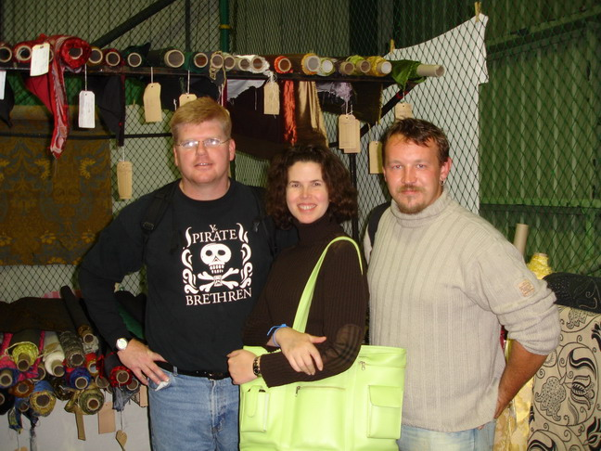
Greg left, Kass (shorter, dark, beautiful) centre, Foxe right.

- Quote
- Edit
- Options

Patrick Hand
- The sailor's sailor
- Moderator

- 6,100 posts
- Gender:Male
- Location:TH' Mountains of Central California
- Interests:I like wierdness... Klingon, Pyrate..... and even..... gasp.... Renn Faires...... (Baseball and tractor pulls I'd have to think about.... could be wierd or Not,,,,)
(IP: 209.78.171.157) · ·
Posted December 28, 2006 · Report post
I though GoF was 6 foot something... So how tall does that make Kass....?

- Quote
- Edit
- Options

Jack Roberts
- Dread Pyrate
- Member

- 1,063 posts
- Gender:Male
- Location:Orlando, FL
(IP: 208.118.10.4) · ·
Posted December 28, 2006 (edited) · Report post
OK where are you? I want to go there and shop. Just seeing the rolls and rolls of fabric behind you makes me drool.
Edited December 28, 2006 by Amanjiria

- Quote
- Edit
- Options

Fox
- Old Twillian
- Moderator

- 2,565 posts
- Gender:Male
- Location:Beautiful lush Devon, England
- Interests:Nautical history of the 16-18th centuries and living history based thereon.
Shooting pirates.
(IP: 217.44.23.182) · ·
Posted December 28, 2006 · Report post
Well I'm 6'1"...
Amanjiria, the photo was taken at the Reenactors' Market at Coventry earlier this year. IIRC the photographer had his back to a musket stall, and I bought a GAoP hanger about three stalls down...

- Quote
- Edit
- Options

kass
- Scourge o' the 7 Seas
- Member

- 1,526 posts
- Gender:Male
- Location:Easton, Pennsylvania
- Interests:Historical Clothing from the 14th through 18th centuries. Getting all the niggling details right. Dressing up and having fun with my similarly-obsessed friends. :)
(IP: 207.172.185.78) · ·
Posted December 28, 2006 · Report post
Patrick Hand said:
I though GoF was 6 foot something... So how tall does that make Kass....?
I LOVE that picture. I look so tiny and petite and feminine... :)
Greg has got to be 6'4" or something. Foxe is 6'1". I'm 5'8" but I think I have better posture than Foxe.
Jack, that's my living room! Doesn't everyone have rolls and rolls of silk as "decor"?

- Quote
- Edit
- Options

Fox
- Old Twillian
- Moderator

- 2,565 posts
- Gender:Male
- Location:Beautiful lush Devon, England
- Interests:Nautical history of the 16-18th centuries and living history based thereon.
Shooting pirates.
(IP: 217.44.23.182) · ·
Posted December 28, 2006 · Report post
A rose between two thorns!
I suspect I was stooping under the weight of all those books you bought Kass

- Quote
- Edit
- Options

kass
- Scourge o' the 7 Seas
- Member

- 1,526 posts
- Gender:Male
- Location:Easton, Pennsylvania
- Interests:Historical Clothing from the 14th through 18th centuries. Getting all the niggling details right. Dressing up and having fun with my similarly-obsessed friends. :)
(IP: 207.172.185.78) · ·
Posted December 28, 2006 · Report post
Don't you mean the voice of sanity keeping you two from buying every shiny pointy thing in sight?
I think you were bowed under the weight of having to put up with me for two weeks.
And as I remember, I carried my own books in my HUGE Kass-green bag! :)

William Brand
- Mercury Malefactor
- Admin

- 8,884 posts
- Gender:Male
- Location:Logan, Utah
- Interests:My name is William Pace and I live and work as a graphic designer, illustrator and photographer in Northern Utah. I'm married to the lovely Tracy Pace and we have three children. In addition to all things art, I enjoy traveling and meeting new people from every walk of life. I've always been a fan of history, theology, and of course, Pyracy.
http://www.youtube.com/watch?v=PSkt-q-HihQ
(IP: 69.19.130.133) · ·
Posted December 28, 2006 · Report post
Sorry. I was actually thinking "Foxe" when I wrote "Gentleman of Fortune".
I've been ill.

- Quote
- Edit
- Options

kass
- Scourge o' the 7 Seas
- Member

- 1,526 posts
- Gender:Male
- Location:Easton, Pennsylvania
- Interests:Historical Clothing from the 14th through 18th centuries. Getting all the niggling details right. Dressing up and having fun with my similarly-obsessed friends. :)
(IP: 207.172.185.78) · ·
Posted December 28, 2006 · Report post
Don't worry about it, William. As the boys said, it happens quite frequently! :)
You're okay... as long as you don't start calling one of them Kass!

- Quote
- Edit
- Options

William Brand
- Mercury Malefactor
- Admin

- 8,884 posts
- Gender:Male
- Location:Logan, Utah
- Interests:My name is William Pace and I live and work as a graphic designer, illustrator and photographer in Northern Utah. I'm married to the lovely Tracy Pace and we have three children. In addition to all things art, I enjoy traveling and meeting new people from every walk of life. I've always been a fan of history, theology, and of course, Pyracy.
http://www.youtube.com/watch?v=PSkt-q-HihQ
(IP: 69.19.130.133) · ·
Posted December 28, 2006 · Report post
kass said:
Don't worry about it, William. As the boys said, it happens quite frequently! :)
You're okay... as long as you don't start calling one of them Kass!
I haven't called GoF "kass" since Paris of '97. Those were the days.

- Quote
- Edit
- Options

kass
- Scourge o' the 7 Seas
- Member

- 1,526 posts
- Gender:Male
- Location:Easton, Pennsylvania
- Interests:Historical Clothing from the 14th through 18th centuries. Getting all the niggling details right. Dressing up and having fun with my similarly-obsessed friends. :)
(IP: 207.172.185.78) · ·
Posted December 28, 2006 · Report post
That was his "long, curly, dark hair and miniskirts" stage if I remember correctly...

- Quote
- Edit
- Options

Jack Roberts
- Dread Pyrate
- Member

- 1,063 posts
- Gender:Male
- Location:Orlando, FL
(IP: 208.118.10.4) · ·
Posted December 28, 2006 (edited) · Report post
Quote
Foxe Posted on Dec 28 2006, 03:48 PM
Well I'm 6'1"...
Amanjiria, the photo was taken at the Reenactors' Market at Coventry earlier this year.
Not to pull off topic here, but CRAP! Thats in the UK. I guess I won't be able to make it there for a awhile. Anything like that state side? Its hard to find decent patterned material here. I found a dicount fabric store and they have some stuff but I'd like to be more period with my fabrics when I can.
Quote
That was his "long, curly, dark hair and miniskirts" stage if I remember correctly... ohmy.gif
I'm a bit scared. I don't think I want to know.
Edited December 28, 2006 by Amanjiria

- Quote
- Edit
- Options

Patrick Hand
- The sailor's sailor
- Moderator

- 6,100 posts
- Gender:Male
- Location:TH' Mountains of Central California
- Interests:I like wierdness... Klingon, Pyrate..... and even..... gasp.... Renn Faires...... (Baseball and tractor pulls I'd have to think about.... could be wierd or Not,,,,)
(IP: 209.78.171.157) · ·
Posted December 28, 2006 · Report post
Quote
I'm a bit scared. I don't think I want to know.
No reason to be scared.... he's got the legs for it.......
Dang.... we are WAYYYYYY off-topic.... ain't we.......

- Quote
- Edit
- Options

William Brand
- Mercury Malefactor
- Admin

- 8,884 posts
- Gender:Male
- Location:Logan, Utah
- Interests:My name is William Pace and I live and work as a graphic designer, illustrator and photographer in Northern Utah. I'm married to the lovely Tracy Pace and we have three children. In addition to all things art, I enjoy traveling and meeting new people from every walk of life. I've always been a fan of history, theology, and of course, Pyracy.
http://www.youtube.com/watch?v=PSkt-q-HihQ
(IP: 69.19.130.133) · ·
Posted December 29, 2006 · Report post
Yes. We are drifting. Helm! Hard to Larboard, if you please.
I have been spending a little time every day going through paintings, especially still lifes of the period. I find that still lifes often show us great hunting pictures and house wares. These often contain little items such as weapons, bags, crockery and so forth. I have yet to find anything in the past few days that shows bags, but I am determined.

- Quote
- Edit
- Options

kass
- Scourge o' the 7 Seas
- Member

- 1,526 posts
- Gender:Male
- Location:Easton, Pennsylvania
- Interests:Historical Clothing from the 14th through 18th centuries. Getting all the niggling details right. Dressing up and having fun with my similarly-obsessed friends. :)
(IP: 207.172.185.78) · ·
Posted December 29, 2006 · Report post
Amanjiria said:
Not to pull off topic here, but CRAP! Thats in the UK. I guess I won't be able to make it there for a awhile. Anything like that state side? Its hard to find decent patterned material here. I found a dicount fabric store and they have some stuff but I'd like to be more period with my fabrics when I can.
Oh Jack... We went off topic long ago...
There is a Reenactors' Market coming up in early February in Chicago. Here's the link to their website: Reenactor Fest
I can't promise you that they'll have the selection that TORM in Coventry did, but it's worth a look if you come North (although WHY you'd want to leave lovely Florida in February, I'll never know... )
There is also an expanding selection of fabrics on certain websites that will remain nameless.

- Quote
- Edit
- Options

kass
- Scourge o' the 7 Seas
- Member

- 1,526 posts
- Gender:Male
- Location:Easton, Pennsylvania
- Interests:Historical Clothing from the 14th through 18th centuries. Getting all the niggling details right. Dressing up and having fun with my similarly-obsessed friends. :)
(IP: 207.172.185.78) · ·
Posted December 29, 2006 · Report post
William Red Wake said:
I have been spending a little time every day going through paintings, especially still lifes of the period. I find that still lifes often show us great hunting pictures and house wares. These often contain little items such as weapons, bags, crockery and so forth. I have yet to find anything in the past few days that shows bags, but I am determined.
To make up for my contribution to this thread going WAY off-topic, here are a couple by Willem Aelst from the late 1660s.
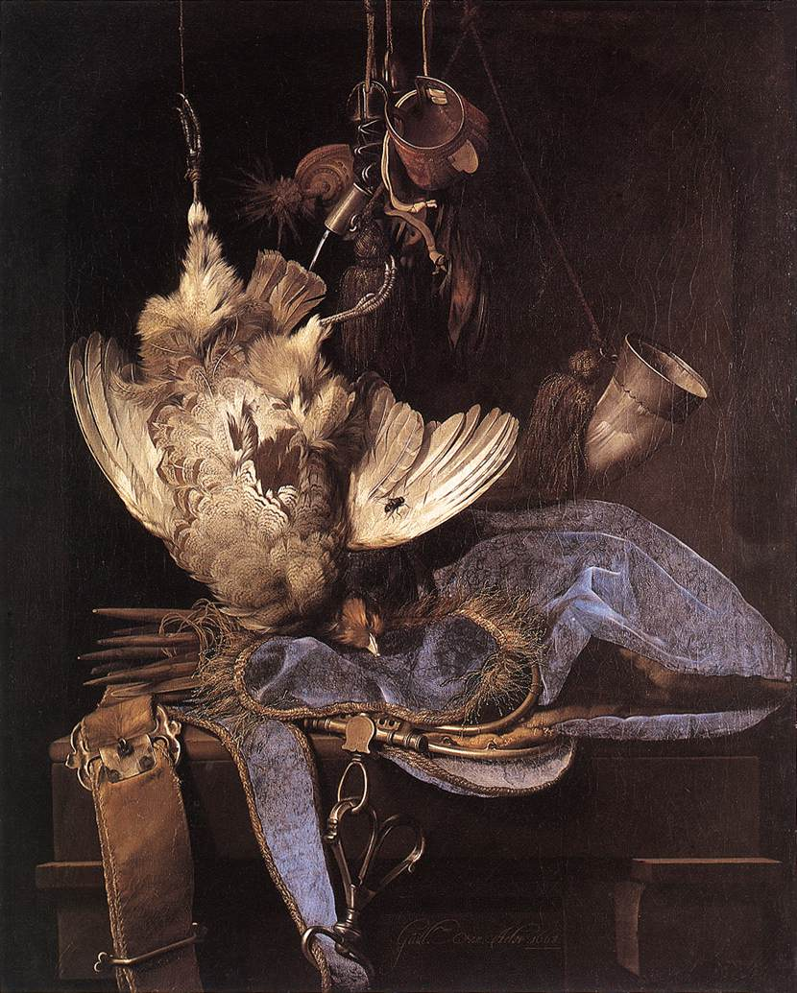
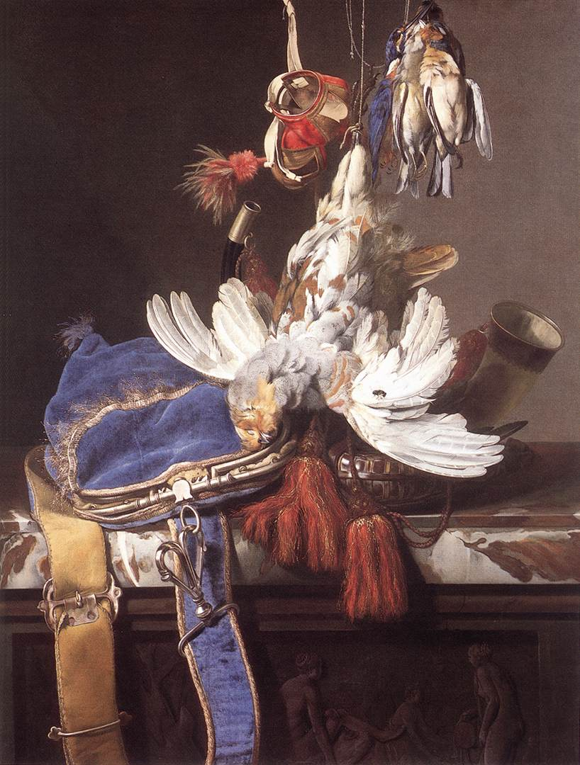
And a long gun and powder horn on a justacorps...
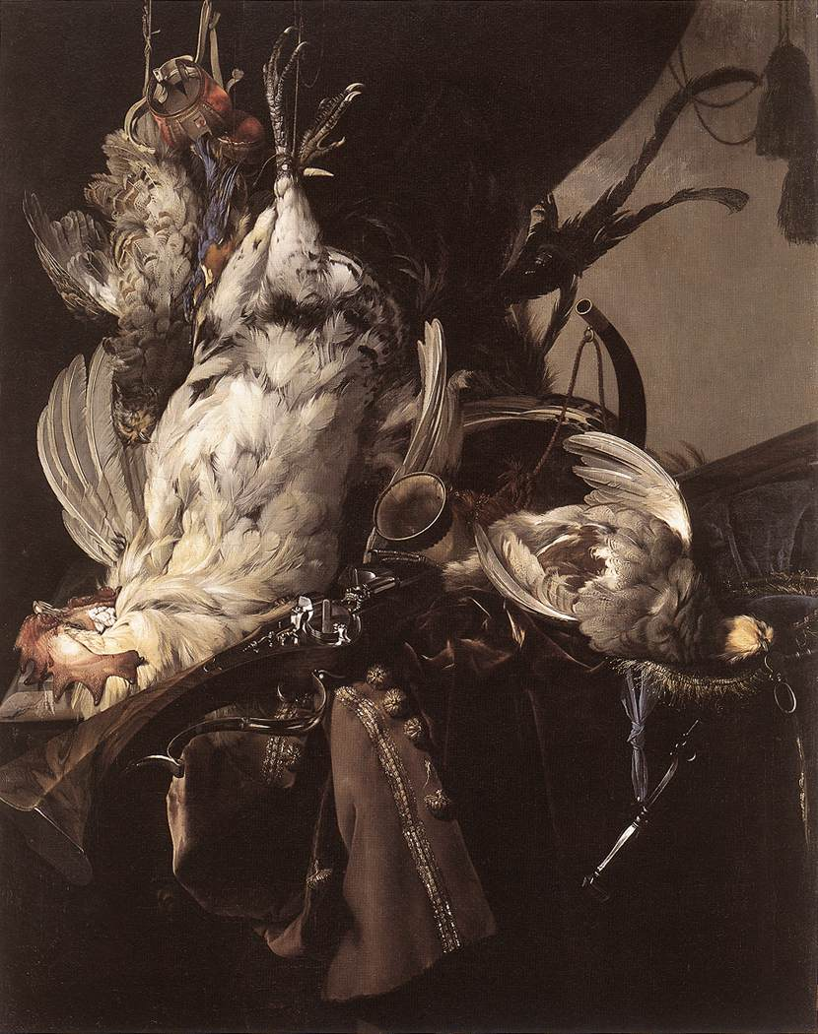
And one by Deportes of himself. This one is 1699. I think there's a hunting bag near his feet...
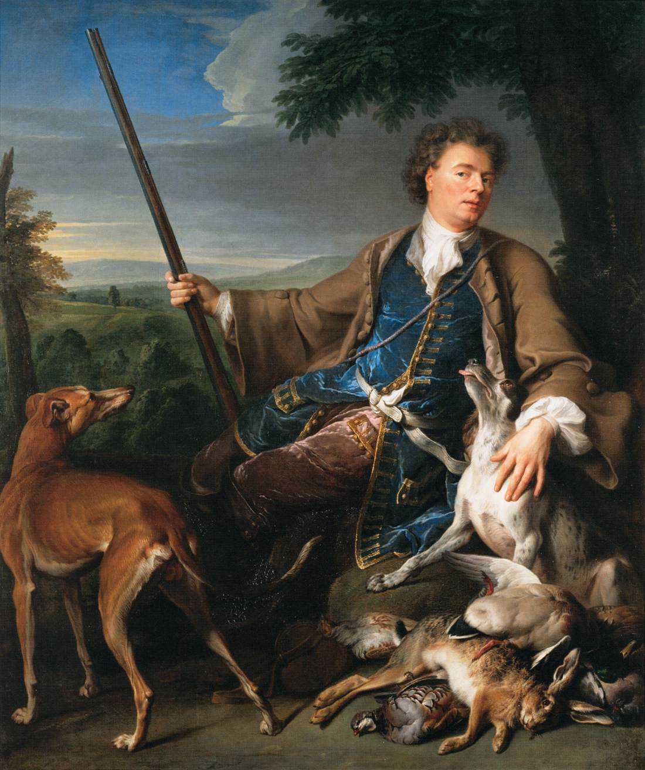

- Quote
- Edit
- Options

Jack Roberts
- Dread Pyrate
- Member

- 1,063 posts
- Gender:Male
- Location:Orlando, FL
(IP: 208.118.10.4) · ·
Posted December 29, 2006 (edited) · Report post
Quote
kass Posted on Dec 29 2006, 08:38 AM
(although WHY you'd want to leave lovely Florida in February, I'll never know... blink.gif )
For the snow of course! We don't get thtat to much down here but seriously. I think I will be in cali for those dates this year. I will have to plan for next year. Thanks.
Wow those painting are gorgeous. Almost as good a photographs. You can see the texture of the fabric.
Edited December 29, 2006 by Amanjiria

- Quote
- Edit
- Options

Captain Jim
- Captain Jim for Captain!
- Member

- 2,254 posts
- Gender:Male
- Location:Off the coast of Tampa Bay (Unfortunately, inland from the coast)
- Interests:I'm 57, formerly a wildlife ecologist and biologist, now a stay-at-home dad. I grew up on the west coast of Florida, where Anna Maria Sound and Tampa Bay were my playground. My interests include, but are not limited to cannon, black powder arms, history, fishing the flats, sailing, fine wood working, flint gun building, hunting, good gun dogs. Above all, my wife and children.
(IP: 207.96.50.26) · ·
Posted December 29, 2006 · Report post
Great Pictures! A couple of comments: those are falconry still lifes. Note the hoods at the top of all three. Also, the "Art of Shooting Flying" (modern wingshooting) was in its infancy and hitting a moving sparrow with the wheellock pictured would be next to impossible. Falcons took the fowl more than likely. The hare in the self-portrait could have been taken with the gun pictured, however. Also, note that the horns are hunting horns, not powder horns. Great pictures.

- Quote
- Edit
- Options

kass
- Scourge o' the 7 Seas
- Member

- 1,526 posts
- Gender:Male
- Location:Easton, Pennsylvania
- Interests:Historical Clothing from the 14th through 18th centuries. Getting all the niggling details right. Dressing up and having fun with my similarly-obsessed friends. :)
(IP: 207.172.185.78) · ·
Posted December 29, 2006 · Report post
I picked these to further illustrate Foxe's post about hawking bags. I presume those are all hawking bags since they're pictured with falcon hoods. Do you agree?
Hunting horns? Oh yeah... They would have to have bottoms to be powder horns, wouldn't they?
What do you want from me, Jim! I'm just a girl!

- Quote
- Edit
- Options

Capt. Bo of the WTF co.
- Scourge o' the 7 Seas
- Member

- 2,339 posts
- Gender:Male
- Location:Spanish Louisiana - on the river Osage
- Interests:Many and varied.
(IP: 4.244.57.201) · ·
Posted December 29, 2006 (edited) · Report post
A blue velvet clasp bag for falconry... WOW! Great details in those paintings. Thanks Kass!
Desportes... are those gaiters or boots he is wearing? The buttons suggest gaiters. What say you?
Bo
Edited December 29, 2006 by Capt. Bo of the WTF co.

- Quote
- Edit
- Options

Jack Roberts
- Dread Pyrate
- Member

- 1,063 posts
- Gender:Male
- Location:Orlando, FL
(IP: 68.243.245.53) · ·
Posted December 29, 2006 · Report post
BOOTs!! Boots... Sorry I'll put my spoon away now.

- Quote
- Edit
- Options

kass
- Scourge o' the 7 Seas
- Member

- 1,526 posts
- Gender:Male
- Location:Easton, Pennsylvania
- Interests:Historical Clothing from the 14th through 18th centuries. Getting all the niggling details right. Dressing up and having fun with my similarly-obsessed friends. :)
(IP: 207.172.185.78) · ·
Posted December 29, 2006 · Report post
Quiet Jack!
Bo, they could be either gaiters or boots. Desportes painted himself in the guise of hunter in this self-portrait. Hunters were mounted so it would not be out of the question for him to be wearing boots.
It's funny. I didn't find this painting in one of my clothing searches. I found it on a site for adopting retired racing greyhounds (I have two). It just so happened that it was dated 1699. :) You'll note the fawn-coloured boy in the foreground is a grey while the other is a bird dog of some type. Strange to be hunting birds with a greyhound. Maybe that hare was his contribution.

- Quote
- Edit
- Options

Patrick Hand
- The sailor's sailor
- Moderator

- 6,100 posts
- Gender:Male
- Location:TH' Mountains of Central California
- Interests:I like wierdness... Klingon, Pyrate..... and even..... gasp.... Renn Faires...... (Baseball and tractor pulls I'd have to think about.... could be wierd or Not,,,,)
(IP: 209.78.171.157) · ·
Posted December 30, 2006 · Report post
I'm looking at the straps.... cloth on one side... leather backed... and braid/ rope on the edge....... coool.....................
anyway.... is anyone interested in an article about how to make a sea bag. or ditty bag... (the only difference is just the size of the thing)......
If no one cares... then .... why bother......
I'm not saying it will be period..... but they do work... and "once apon a tyme" people wern't stupid... they made things that worked....

- Quote
- Edit
- Options

Dorian Lasseter
- Where's My Water
- Member

- 3,266 posts
- Gender:Male
- Location:The Sea!
- Interests:18th Century reenactment; Maritime, F&I...
Did ECW as well...
All BP firelocks and cannons!
Also enjoy Swordfighting and a good Donnybrook
Got a question for or about me? Ask!!!
(IP: 67.186.14.161) · ·
Posted December 30, 2006 · Report post
Patrick my goode man...
I do believe that is the intent of this thread!
I want a sea bag, a ditty bag, a snapsack, etc....
I had a nice canvas drawstring top bag I used to use... it died awhile back...
I have 'created out of necessity' other canvas bags as well... nothing fancy.
But..... I want, need, the nifty sailor's bags! and eventually a sea chest, and a ship to put it all in!

- Quote
- Edit
- Options

Capt. Sterling
- Sticky Fingers Sterling Needs a New Hat
- Member

- 10,302 posts
- Gender:Pyrate Hunter
- Location:here
- Interests:Killing pirates, haven't met one yet worth keeping alive....
(IP: 76.1.130.73) · ·
Posted December 30, 2006 · Report post
Dorian Lasseter said:
and eventually a sea chest, and a ship to put it all in!
Don't we all?!

- Quote
- Edit
- Options

William Brand
- Mercury Malefactor
- Admin

- 8,884 posts
- Gender:Male
- Location:Logan, Utah
- Interests:My name is William Pace and I live and work as a graphic designer, illustrator and photographer in Northern Utah. I'm married to the lovely Tracy Pace and we have three children. In addition to all things art, I enjoy traveling and meeting new people from every walk of life. I've always been a fan of history, theology, and of course, Pyracy.
http://www.youtube.com/watch?v=PSkt-q-HihQ
(IP: 69.19.130.133) · ·
Posted December 30, 2006 · Report post
Thank you, Kass. I'm sorely tempted to duplicate that ornate clip on the bag.

- Quote
- Edit
- Options

Patrick Hand
- The sailor's sailor
- Moderator

- 6,100 posts
- Gender:Male
- Location:TH' Mountains of Central California
- Interests:I like wierdness... Klingon, Pyrate..... and even..... gasp.... Renn Faires...... (Baseball and tractor pulls I'd have to think about.... could be wierd or Not,,,,)
(IP: 209.78.171.157) · ·
Posted December 30, 2006 · Report post
Quote
I do believe that is the intent of this thread!
Awh heck... at least I can say that "Im' happly drunk right now........
I've made a Sea bag, a few ditty bags, and a snap sack..... if anyone is interested, I can tell them what or how I did so.......

- Quote
- Edit
- Options

Capt. Sterling
- Sticky Fingers Sterling Needs a New Hat
- Member

- 10,302 posts
- Gender:Pyrate Hunter
- Location:here
- Interests:Killing pirates, haven't met one yet worth keeping alive....
(IP: 76.1.130.73) · ·
Posted December 30, 2006 · Report post
William Red Wake said:
Thank you, Kass. I'm sorely tempted to duplicate that ornate clip on the bag.
William if you look for swivel clips for dragoon carbine slings, such as used by Am. Rev. War types you may be able to figure out how to weld two together to get that look....

- Quote
- Edit
- Options

William Brand
- Mercury Malefactor
- Admin

- 8,884 posts
- Gender:Male
- Location:Logan, Utah
- Interests:My name is William Pace and I live and work as a graphic designer, illustrator and photographer in Northern Utah. I'm married to the lovely Tracy Pace and we have three children. In addition to all things art, I enjoy traveling and meeting new people from every walk of life. I've always been a fan of history, theology, and of course, Pyracy.
http://www.youtube.com/watch?v=PSkt-q-HihQ
(IP: 69.19.130.133) · ·
Posted December 30, 2006 · Report post
Capt. Sterling said:
William Red Wake said:
Thank you, Kass. I'm sorely tempted to duplicate that ornate clip on the bag.
William if you look for swivel clips for dragoon carbine slings, such as used by Am. Rev. War types you may be able to figure out how to weld two together to get that look....
I'm a sculptor actually with ties in the casting world...bronse, silver and the like, but that isn't a bad idea.

- Quote
- Edit
- Options

Capt. Sterling
- Sticky Fingers Sterling Needs a New Hat
- Member

- 10,302 posts
- Gender:Pyrate Hunter
- Location:here
- Interests:Killing pirates, haven't met one yet worth keeping alive....
(IP: 76.1.130.73) · ·
Posted December 30, 2006 (edited) · Report post
Well then if you were at least to get your hands on one to get size, ect, maybe that would be all you need... I'll check with dad and see if he still has any....
Edited December 30, 2006 by Capt. Sterling

- Quote
- Edit
- Options

Edward T. Porter
- Deck Hand
- Member

- 64 posts
- Location:Bremen, Germany
- Interests:-LIVE ACTION ROLE PLAYING/ LARP<br>-Sewing my clothes<br>-History<br>-Poker<br><br>Roles I Play in Larp:<br><br>Edward T. Porter (Pirate, 1760´s)<br>Weland Pommery (Pirate 1720´s)<br>Tadeo di Seda (spanish rennaissance swashbuckler)
(IP: 91.64.22.219) · ·
Posted January 11, 2007 · Report post
snapsacks and wallets
It´s post GaoP but still interesting.

- Quote
- Edit
- Options

William Brand
- Mercury Malefactor
- Admin

- 8,884 posts
- Gender:Male
- Location:Logan, Utah
- Interests:My name is William Pace and I live and work as a graphic designer, illustrator and photographer in Northern Utah. I'm married to the lovely Tracy Pace and we have three children. In addition to all things art, I enjoy traveling and meeting new people from every walk of life. I've always been a fan of history, theology, and of course, Pyracy.
http://www.youtube.com/watch?v=PSkt-q-HihQ
(IP: 166.70.59.121) · ·
Posted January 14, 2007 · Report post
Edward T. Porter said:
snapsacks and wallets
It´s post GaoP but still interesting.
Aye, I've seen that one before. That is a very good site.

• Quote
• Edit
• Options

MadL
- Dread Pyrate
- Member

- 1,283 posts
- Gender:Male
- Location:Where ever I need ta be
- Interests:I like pirates, ye got a problem with that?
Blame me mu'm, she the one who decked me room out like a captain's cabin an' that be what I grew'd up in. Also me pa fer he built boats when I was but a wee lad. Later they ran off an' joined the carnivals, so I learn ta be a scalawag from the best.
I like weapons, some that go BOOM, and always sharp shiny ones.
I work with computers, currently contracted to hire by Xerox, their engineers [I]Need[/I] all the help they can get, this is fer sure! But I also have taught the Microsoft Certification course for a private contact school, an' spent 4 years working third level support at Earthlink before that scalawag Sky jumped ship an' let it go down.
They call me Mad L cuz, well, cuz many think I be mad, mad as a hatter they say but that only because they never jumped from a perfectly good airplane....over a thousand times. They also call me Mad L cuz I don't much like dogs n' cats, but I like things with scales and teeth, even the venomous ones for they be quit tasty when roasted over an open flame....even bet'r wit rum! They also call me Mad L, well, cuz very few know how to say me sir name properly, so in the military they give up and just call me "Mad L"
Oh, an' I dabble in the arts, computer 3D arts that be. Thar they all think I be mad, I do me best to make sure they all know I be mad. I have fun run'n amok as a pirate monkey character and makin' the moderators thar go bald. Several times the moderators try ta toss me o'r board, but the crew say will have none o' that now ;\
So, I like pirates, ye got a problem with that?
(IP: 4.131.153.227) · ·
Posted January 18, 2009 · Report post
Aye, I be bring'n up an old subject - who wanta make somth'n o' it?!!
Aye, I recently ran across a gent who fancy he'm self an old salt with vast experience and research in Sail. He was advertising, among other things, a book he has wrote on Ditty and Seamen Bags with several designs and descriptions right down t' th' stitching and hems.
Well, I need work on me sewing skills ('er lack of) so inquired if he still had th' book see'n as how there be no internet purchase button nor date t' tell me how old th' page may even be, he wrote right back same day!
As he indicated he spent much time int' he's research I ask'd if he had any insight t' sails o' th' GAoP period (indicating 1650~1730), well, he's first comeback was rather short - apparently he be, as he stated, o' Old School 'n feels all pirates should be hung on sight 'n therefore had non else t' say on th' matter!
So, I figured I better parlay with this gent...'n FAST, else find me self dance'n in th' jig!. So I wrote he'm back 'n began t' explain th' diversified group o' Pirate Reenactors 'n Pirate Festivals that are found across th' country and around th' world, I began t' explain, expressing that I can only speak of me self but felt it pretty much represented th' community as a whole, that we did not "celebrate cutthroats, killers, and thieves" but more expressed on the more positive aspects on pirates in history - I went int' a speel on Captain Drake, privateers, buccaneers, explorers, and in general 'free men' who did what they had to in order to survive in hard times with corrupt governments and rulers. I explained that among those I have come t' know th' Pirate Reenactment Community includes; school teachers, actors, reenactors, historians, general enthusiasts, and o' course sailors....and an occasional Jack Sparrow that we keep around; because every ship needs a cabin boy, and for some reason th' general public really relate t' th' cur.
With that he seem'd t' lighten up, he explained that has worked with reenactors but more of Ren Faire and Viking reenactors, said he had never ran int' any pirates. He said he was very put off by those he worked with for he felt they were not int' "authenticity" but more driven by Hollywood movies and would give him much argument when he tried to show them how things where made. I wrote back again explaining some of the forums like here at th' Pub and told he'm about Gentlemen of Fortune, I explained that while some pirate reenactors go t' great length t' research and be as authentic as possible right down t' th' very stitching o' every item while others strive t' do th' best they can with limited budget and time between real jobs....with that I seem'd t' have touched him for he wrote back th' following:
--------------
Aye Mad L,
Good show, my compliments.
1. From what I could gather when I did the first active research on ditty bags in 1990. I could find NOTHING on ditty bags or indication of ditty bags before the early quarter of the 19th century. NOW, this does not say they didn't exist in some form or another, no proof so I didn't stand on that but I looked THOURGHLY. What I gather the "early" seaman
wrapped/gathered up a cloth with there personal items(which was extremely little) and then tied off. At present I can't put any effort into digging into any of this since I am now working on(other than the BIG)a book on making a traditional canvas ships bucket. (Buckets-4 different styles - pre 1940)
2. Now the "chest" was only had by the wealthy, evidenced by items from the reclamation of the Mary Rose 1549 and the VASA - 1628 in Sweden(on which I have done extensive work on the sail remnants for years now),, where they
brought up chests and boxes with some fantastic items NOTHING the common seaman or low level officer could possibly afford. Now from what information I could put together, on the VASA -1628 seaman(position could not be accurately determined) had personal items in small barrels with lid wedged on the top. From what I could determine one had had some canvas fastened to the lid but there is question on this. Small coopered barrels were FAR easier to come by than a "chest". I am short of time and can't go into this with anymore detail but it will give you folks an overview.
(he then went on t' tell me o' a Fashion Show he's wife "roped" him into and the early 1900 Swedish seaman's "Bassarong" he made and dress of same era he's wife made; all hand made and hand dyed)
-----------------------
Anyway, I will let ye know how he's book be when it arrives.
"Making a Sailor's Traditional Ditty & Sea Bag"

- Quote
- Edit
- Options

Mary Diamond
- It's My Fault
- Moderator

- 1,050 posts
- Gender:Female
- Location:Illinois
- Interests:Things I Love: Horticulture, Travel, Volleyball, Reading, Sewing, Costuming, Halloween, esp. props!, Halo, Halo2, Halo3, ODST, and, of course, Pyracy.
(IP: 24.13.221.117) · ·
Posted January 19, 2009 · Report post
Fascinating! and much obliged to you, MadL, for your excellent communications. Interesting that barrels are the poor man's alternative to a sea chest ~ now all we (the collective, of course) need do is shanghai a cooper, and we shall be set...

- Quote
- Edit
- Options

Patrick Hand
- The sailor's sailor
- Moderator

- 6,100 posts
- Gender:Male
- Location:TH' Mountains of Central California
- Interests:I like wierdness... Klingon, Pyrate..... and even..... gasp.... Renn Faires...... (Baseball and tractor pulls I'd have to think about.... could be wierd or Not,,,,)
(IP: 207.104.49.59) · ·
Posted January 19, 2009 · Report post
He sound kinda like a jerk.....
But a jerk we wanna know.....
Yeah... that may not have typed out right, it was not meant offensive, but it does take some time to get to know that we are all not Jack Sparrow wannabe's.....
Or something like that......
Yeah... it didn't type out right......

- Quote
- Edit
- Options

MadL
- Dread Pyrate
- Member

- 1,283 posts
- Gender:Male
- Location:Where ever I need ta be
- Interests:I like pirates, ye got a problem with that?
Blame me mu'm, she the one who decked me room out like a captain's cabin an' that be what I grew'd up in. Also me pa fer he built boats when I was but a wee lad. Later they ran off an' joined the carnivals, so I learn ta be a scalawag from the best.
I like weapons, some that go BOOM, and always sharp shiny ones.
I work with computers, currently contracted to hire by Xerox, their engineers [I]Need[/I] all the help they can get, this is fer sure! But I also have taught the Microsoft Certification course for a private contact school, an' spent 4 years working third level support at Earthlink before that scalawag Sky jumped ship an' let it go down.
They call me Mad L cuz, well, cuz many think I be mad, mad as a hatter they say but that only because they never jumped from a perfectly good airplane....over a thousand times. They also call me Mad L cuz I don't much like dogs n' cats, but I like things with scales and teeth, even the venomous ones for they be quit tasty when roasted over an open flame....even bet'r wit rum! They also call me Mad L, well, cuz very few know how to say me sir name properly, so in the military they give up and just call me "Mad L"
Oh, an' I dabble in the arts, computer 3D arts that be. Thar they all think I be mad, I do me best to make sure they all know I be mad. I have fun run'n amok as a pirate monkey character and makin' the moderators thar go bald. Several times the moderators try ta toss me o'r board, but the crew say will have none o' that now ;\
So, I like pirates, ye got a problem with that?
(IP: 4.131.157.202) · ·
Posted January 19, 2009 (edited) · Report post
Patrick Hand said:
He sound kinda like a jerk..........
Yeah... it didn't type out right......
I have received similar remark from others when first they hear I portray a pirate, usually from those who have never heard of a Pirate Festival or reenactment but only know of Ren Faire, usually from those who believe only in th' literal word and definition "Pirate = murderous cutthroat thieve", usually from those who have no knowledge of good men who once when t' war for a king or queen and upon returning home with great joy of victory only to have their joy shattered as they find they are now regarded as 'Pirates' and have become automatic 'wanted men' all because they did not get word in time t' stop fighting. Many know of how Hollywood either 'glorifies' or 'villinize' pirates but in their own minds regards any who be tagged one a criminal....for me at least, it depends on what side of the coin ye be reading th' story, and yes, before ye jump, aye, I do know there also be 'really bad eggs' in history as well, as well as in present - think about it, just because someone puts on a cop's uniform (either legally or illegally) is he to be given full trust and respect? I know some dead people who would debate th' point (my own security training when servicing auto tellers taught me t' "Beware A Man In Uniform At ALL Costs!" -and if ye ever served military in Georgia then ye may also know where I come from as well))....just because one puts on religious cloth are they a man of God? I think modern day news and stories throughout history answer that one....I feel what be good for the goose be good for the gander; if we know all that be 'seen as good' is not always good then what be 'seen as bad' may have their own side t' th' coin t' tell if one is only willing t' listen.
Once this was pointed out t' Master Bartos he no longer seem'd a "jerk" and I extended invitation t' him for a visit t' th' Pub, it may be a while for him t' come round however as he do seem a busy man....I will be watching for his Canvas Buckets as well.
Edited January 19, 2009 by MadL

- Quote
- Edit
- Options

MadL
- Dread Pyrate
- Member

- 1,283 posts
- Gender:Male
- Location:Where ever I need ta be
- Interests:I like pirates, ye got a problem with that?
Blame me mu'm, she the one who decked me room out like a captain's cabin an' that be what I grew'd up in. Also me pa fer he built boats when I was but a wee lad. Later they ran off an' joined the carnivals, so I learn ta be a scalawag from the best.
I like weapons, some that go BOOM, and always sharp shiny ones.
I work with computers, currently contracted to hire by Xerox, their engineers [I]Need[/I] all the help they can get, this is fer sure! But I also have taught the Microsoft Certification course for a private contact school, an' spent 4 years working third level support at Earthlink before that scalawag Sky jumped ship an' let it go down.
They call me Mad L cuz, well, cuz many think I be mad, mad as a hatter they say but that only because they never jumped from a perfectly good airplane....over a thousand times. They also call me Mad L cuz I don't much like dogs n' cats, but I like things with scales and teeth, even the venomous ones for they be quit tasty when roasted over an open flame....even bet'r wit rum! They also call me Mad L, well, cuz very few know how to say me sir name properly, so in the military they give up and just call me "Mad L"
Oh, an' I dabble in the arts, computer 3D arts that be. Thar they all think I be mad, I do me best to make sure they all know I be mad. I have fun run'n amok as a pirate monkey character and makin' the moderators thar go bald. Several times the moderators try ta toss me o'r board, but the crew say will have none o' that now ;\
So, I like pirates, ye got a problem with that?
(IP: 4.131.158.188) · ·
Posted January 20, 2009 · Report post
A new tidbit of information just came to me from Master Bartos, author of "Making a Salior's Ditty Bag, Sea Bag", he just wrote to tell me that he is seeking the rough draft of a book he began to write a while back called "Seaman's Luggage", he said he abandoned the idea after interviewing some, and I quote: "large group of OLD sailors(real sailors)" and they told him that 'Luggage' was insulting to true sailors stating "We have Sea Bags and Sea Chests".
He said once he finds his old rough draft of what he had written he will scan it in for me look through...sounds interesting.
Just remember; Sailors toss old luggage overboard for them ungrateful tourists, a true Sailor only carries what is necessary and carries it in a proper bag or chest
(bloody tourists!)

- Quote
- Edit
- Options

Capt. Bo of the WTF co.
- Scourge o' the 7 Seas
- Member

- 2,339 posts
- Gender:Male
- Location:Spanish Louisiana - on the river Osage
- Interests:Many and varied.
(IP: 64.85.215.31) · ·
Posted January 22, 2009 (edited) · Report post
My sister has dubbed them "TOURONS" which is a combination of tourist and moron.
I love it!
I have also made an oversized market wallet that can be documented to the 1680's. It is big enough to use as a pack over a horses back, or as a matress if stuffed with straw. I keep a blanket rolled up in it but can easily shift it's use as need arises. I don't recall the exact measurements, but next time I get the camera out I'll include it in the set. These things are the most versitile and well documented method of carrying things I know of. Very handy and unlimited uses.
Bo
Edited January 22, 2009 by Capt. Bo of the WTF co.

- Quote
- Edit
- Options

Monterey Jack
- Plunderer
- Member

- 441 posts
- Location:Pacific Northwest/ Eugene, OR.
- Interests:Stage Combat Choreography, Historical Maritime Weaponry and tactics, Caribbean History, Leatherwork, Sailing
(IP: 66.224.230.81) · ·
Posted January 22, 2009 · Report post
Capt. Bo of the WTF co. said:
My sister has dubbed them "TOURONS" which is a combination of tourist and moron.
I love it!
I have also made an oversized market wallet that can be documented to the 1680's. It is big enough to use as a pack over a horses back, or as a matress if stuffed with straw. I keep a blanket rolled up in it but can easily shift it's use as need arises. I don't recall the exact measurements, but next time I get the camera out I'll include it in the set. These things are the most versitile and well documented method of carrying things I know of. Very handy and unlimited uses.
Bo
My day job specializes in leather of all kinds for all purposes, so if anyone feels they want to go from canvas to leather for these items drop me a note at www.oregonleatherco.com and I'll see what i can do.

- Quote
- Edit
- Options

MadL
- Dread Pyrate
- Member

- 1,283 posts
- Gender:Male
- Location:Where ever I need ta be
- Interests:I like pirates, ye got a problem with that?
Blame me mu'm, she the one who decked me room out like a captain's cabin an' that be what I grew'd up in. Also me pa fer he built boats when I was but a wee lad. Later they ran off an' joined the carnivals, so I learn ta be a scalawag from the best.
I like weapons, some that go BOOM, and always sharp shiny ones.
I work with computers, currently contracted to hire by Xerox, their engineers [I]Need[/I] all the help they can get, this is fer sure! But I also have taught the Microsoft Certification course for a private contact school, an' spent 4 years working third level support at Earthlink before that scalawag Sky jumped ship an' let it go down.
They call me Mad L cuz, well, cuz many think I be mad, mad as a hatter they say but that only because they never jumped from a perfectly good airplane....over a thousand times. They also call me Mad L cuz I don't much like dogs n' cats, but I like things with scales and teeth, even the venomous ones for they be quit tasty when roasted over an open flame....even bet'r wit rum! They also call me Mad L, well, cuz very few know how to say me sir name properly, so in the military they give up and just call me "Mad L"
Oh, an' I dabble in the arts, computer 3D arts that be. Thar they all think I be mad, I do me best to make sure they all know I be mad. I have fun run'n amok as a pirate monkey character and makin' the moderators thar go bald. Several times the moderators try ta toss me o'r board, but the crew say will have none o' that now ;\
So, I like pirates, ye got a problem with that?
(IP: 4.131.136.236) · ·
Posted January 22, 2009 · Report post
Aye, I made me own Market Wallet of standard sizing out of heavy canvas weight hemp. It be great for carrying all that stuff what do not fit int' yer pockets or tiny belt pouch!.
I saw someone who was making them with a tie strap on th' ends so after ye toss it over yer shoulder ye could tie th' tabs around yer (on th' other side o' ye) so it now stays put and will not keep slipping off yer shoulder. Mine also be small enough that I can drape it over th' hilt o' me sword or even a large belt dagger and let it hang from me hip. I love th' market wallet!

- Quote
- Edit
- Options

sutlerjon
- Plunderer
- 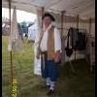
- Member

- 491 posts
- Gender:Male
- Location:Orlando - ish, Fl
(IP: 72.188.166.41) · ·
Posted February 10, 2009 · Report post
I just finished this "snapsack" I may have gone too far back in time as it seems to be documented to the early 1600's, the photos didn't seem to indicate any buttonholes for a "drawstring" and seems to be twisted like a tootsie roll wrapper and tied off and then tied to Tumpline. I looked at a fair number of ECW pics and found several variations on the theme, but they seem to a bit more "modern" with drawstrings and integral straps.
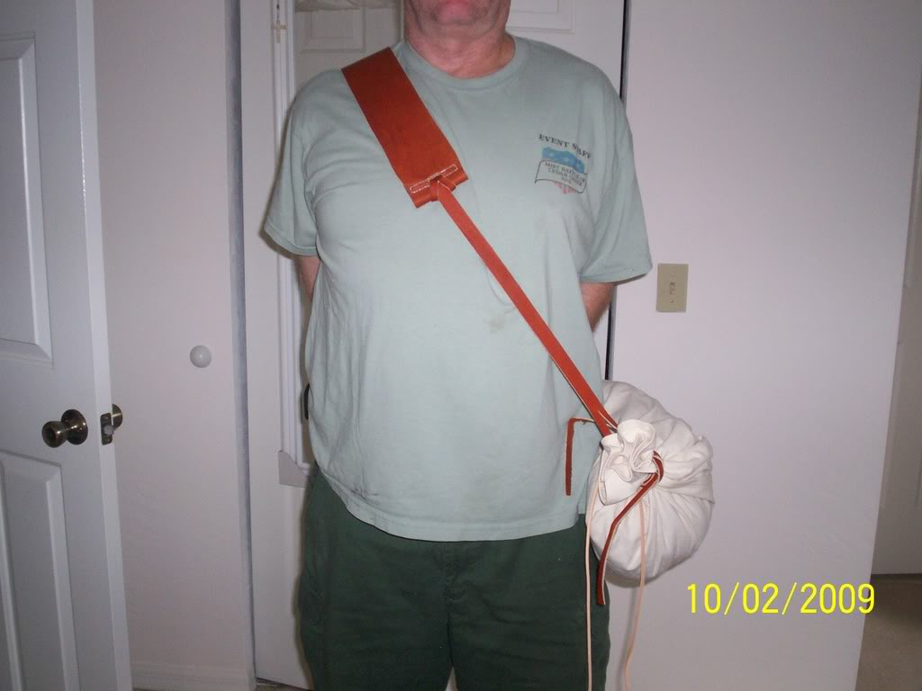
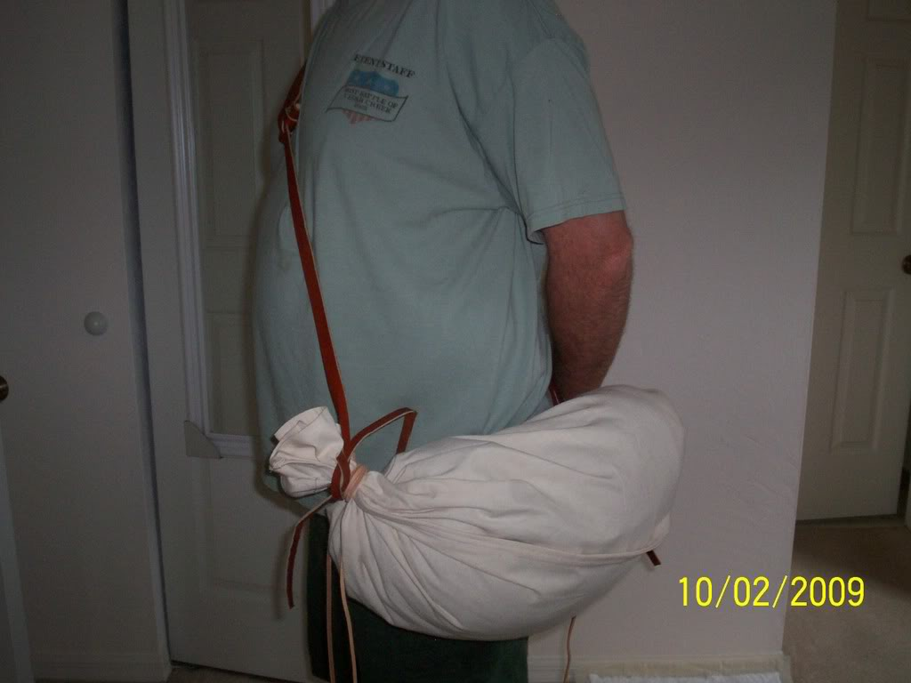
It'll hold a ton of stuff and the 3" wide strap seem very comfortable, probably appropriate for the time of Searles' Raid.
Jim

- Quote
- Edit
- Options

sutlerjon
- Plunderer
- Member

- 491 posts
- Gender:Male
- Location:Orlando - ish, Fl
(IP: 72.188.165.210) · ·
Posted March 3, 2009 · Report post
This is a new snapsack, a work still in progress. I have to out grommets in for tying shut. The design for this came from southern rangers site. It's about 12" across and 36" long.
I think I'll increase diameter and decrease length on the "production model".
It's long enough that it takes 2 pics to get it all in.
open end
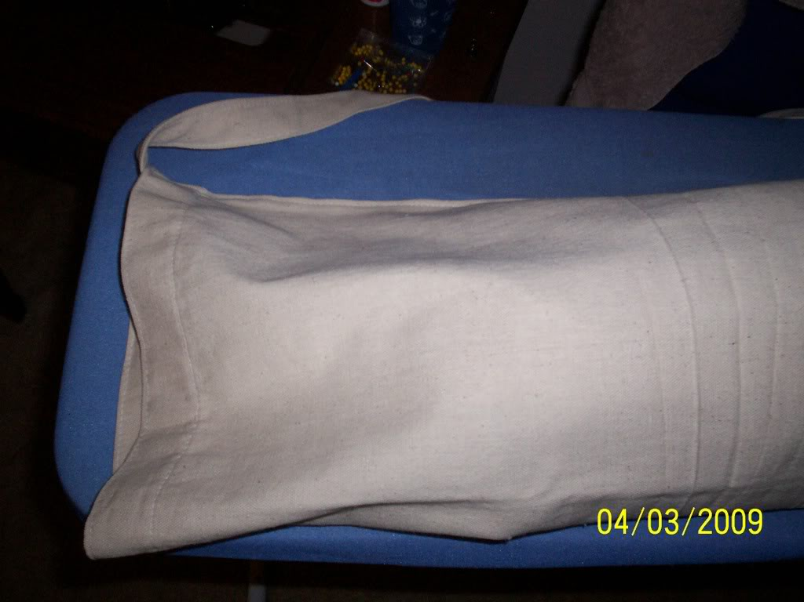
closed end
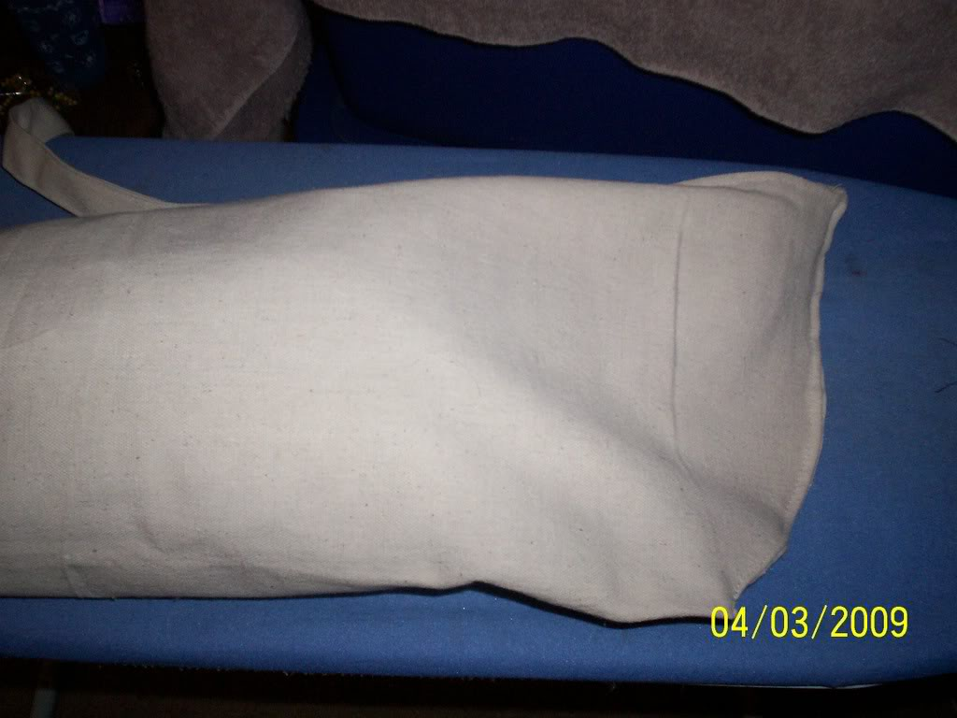
strap is about 40" long but will likely be shortened.
Let me know what ya think,
Jim

- Quote
- Edit
- Options

William Brand
- Mercury Malefactor
- Admin

- 8,884 posts
- Gender:Male
- Location:Logan, Utah
- Interests:My name is William Pace and I live and work as a graphic designer, illustrator and photographer in Northern Utah. I'm married to the lovely Tracy Pace and we have three children. In addition to all things art, I enjoy traveling and meeting new people from every walk of life. I've always been a fan of history, theology, and of course, Pyracy.
http://www.youtube.com/watch?v=PSkt-q-HihQ
(IP: 166.70.59.121) · ·
Posted March 4, 2009 · Report post
MadL said:
1. From what I could gather when I did the first active research on ditty bags in 1990. I could find NOTHING on ditty bags or indication of ditty bags before the early quarter of the 19th century. NOW, this does not say they didn't exist in some form or another, no proof so I didn't stand on that but I looked THOURGHLY. What I gather the "early" seaman
wrapped/gathered up a cloth with there personal items(which was extremely little) and then tied off.
You can see this form of 'tied up bag or cloth' represented in early art, generally being carried on the end of a good stick. I've seen the stick come up in several discussion, but people seldom add it to their kit. I inherited some very nice apple wood branches from my Dad's fruit trees this year and I plan to do a stick and bag combination for PIP.

- Quote
- Edit
- Options

Hawkyns
- Curmudgeon With A Cannon
- Moderator

- 1,330 posts
- Gender:Male
- Location:New Haven Colony
- Interests:cannon, swords, cannon, wenches, cannon, muskets, cannon, pistols, cannon, re-enacting, cannon, rum, cannon, living history......... Did I mention cannon?
(IP: 75.58.115.117) · ·
Posted March 4, 2009 · Report post
Snapsacks were still being used up into the F&I period, so they would still be correct for GAoP. Whether they would be carried be sailors is another question. The one you are making sounds a bit big. Mine is about 20 inches long and 10 inches in diameter. Enough for a spare shirt, spare hose, bowl, spoon and a tin mug/boiler and 2 days rations, as was supposed to be for ECW soldiers. When worn, it sits from right shoulder to left hip, tight across the back. I've seen them made from hemp canvas or thin leather. They're not supposed to be holdalls, but marching packs for soldiers.
Hawkyns

- Quote
- Edit
- Options

MadL
- Dread Pyrate
- Member

- 1,283 posts
- Gender:Male
- Location:Where ever I need ta be
- Interests:I like pirates, ye got a problem with that?
Blame me mu'm, she the one who decked me room out like a captain's cabin an' that be what I grew'd up in. Also me pa fer he built boats when I was but a wee lad. Later they ran off an' joined the carnivals, so I learn ta be a scalawag from the best.
I like weapons, some that go BOOM, and always sharp shiny ones.
I work with computers, currently contracted to hire by Xerox, their engineers [I]Need[/I] all the help they can get, this is fer sure! But I also have taught the Microsoft Certification course for a private contact school, an' spent 4 years working third level support at Earthlink before that scalawag Sky jumped ship an' let it go down.
They call me Mad L cuz, well, cuz many think I be mad, mad as a hatter they say but that only because they never jumped from a perfectly good airplane....over a thousand times. They also call me Mad L cuz I don't much like dogs n' cats, but I like things with scales and teeth, even the venomous ones for they be quit tasty when roasted over an open flame....even bet'r wit rum! They also call me Mad L, well, cuz very few know how to say me sir name properly, so in the military they give up and just call me "Mad L"
Oh, an' I dabble in the arts, computer 3D arts that be. Thar they all think I be mad, I do me best to make sure they all know I be mad. I have fun run'n amok as a pirate monkey character and makin' the moderators thar go bald. Several times the moderators try ta toss me o'r board, but the crew say will have none o' that now ;\
So, I like pirates, ye got a problem with that?
(IP: 67.150.13.209) · ·
Posted March 4, 2009 · Report post
I am still waiting for him t' write th' book on barrels, th' author says he is in midst of another project surrounding a post GAoP ship right now and is also writting a book on canvas water buckets, but I have him on me list t' watch.

- Quote
- Edit
- Options

Cascabel
- Evil Drooling Henchman
- Moderator

- 848 posts
- Gender:Male
(IP: 72.148.237.64) · ·
Posted March 4, 2009 · Report post
Hawkyns said:
Snapsacks were still being used up into the F&I period, so they would still be correct for GAoP. Whether they would be carried be sailors is another question. The one you are making sounds a bit big. Mine is about 20 inches long and 10 inches in diameter. Enough for a spare shirt, spare hose, bowl, spoon and a tin mug/boiler and 2 days rations, as was supposed to be for ECW soldiers. When worn, it sits from right shoulder to left hip, tight across the back. I've seen them made from hemp canvas or thin leather. They're not supposed to be holdalls, but marching packs for soldiers.
Hawkyns
I have sort of wondered why a sailor would be carrying such a thing, unless he was currently un-employed. I suspect that whatever belongings he owned would normally be stowed aboard the ship he was with, and not be constantly carried around when he was ashore. Except, of course, on some kind of overland march of some kind, like the 'Sack of Panama'.
>>>> Cascabel

- Quote
- Edit
- Options

MadL
- Dread Pyrate
- Member

- 1,283 posts
- Gender:Male
- Location:Where ever I need ta be
- Interests:I like pirates, ye got a problem with that?
Blame me mu'm, she the one who decked me room out like a captain's cabin an' that be what I grew'd up in. Also me pa fer he built boats when I was but a wee lad. Later they ran off an' joined the carnivals, so I learn ta be a scalawag from the best.
I like weapons, some that go BOOM, and always sharp shiny ones.
I work with computers, currently contracted to hire by Xerox, their engineers [I]Need[/I] all the help they can get, this is fer sure! But I also have taught the Microsoft Certification course for a private contact school, an' spent 4 years working third level support at Earthlink before that scalawag Sky jumped ship an' let it go down.
They call me Mad L cuz, well, cuz many think I be mad, mad as a hatter they say but that only because they never jumped from a perfectly good airplane....over a thousand times. They also call me Mad L cuz I don't much like dogs n' cats, but I like things with scales and teeth, even the venomous ones for they be quit tasty when roasted over an open flame....even bet'r wit rum! They also call me Mad L, well, cuz very few know how to say me sir name properly, so in the military they give up and just call me "Mad L"
Oh, an' I dabble in the arts, computer 3D arts that be. Thar they all think I be mad, I do me best to make sure they all know I be mad. I have fun run'n amok as a pirate monkey character and makin' the moderators thar go bald. Several times the moderators try ta toss me o'r board, but the crew say will have none o' that now ;\
So, I like pirates, ye got a problem with that?
(IP: 67.150.173.77) · ·
Posted March 4, 2009 · Report post
But Cascabel, where would he keep all th' photos o' all th' tarts 'n strumpets he meets at all them ports they travel?? Ye know they did naught yet have "wallet size" back then!

- Quote
- Edit
- Options

Quartermaster James
- LUNATIC
- Member

- 1,662 posts
- Gender:Male
- Location:Sailing the Islets of Langerhans
- Interests:Interests cannot be left blank, so the machine says.
(IP: 71.39.7.30) · ·
Posted March 4, 2009 · Report post
MadL said:
But Cascabel, where would he keep all th' photos o' all th' tarts 'n strumpets he meets at all them ports they travel?? Ye know they did naught yet have "wallet size" back then!
Don't forget the Hershey bars and nylons!

- Quote
- Edit
- Options

Cascabel
- Evil Drooling Henchman
- Moderator

- 848 posts
- Gender:Male
(IP: 72.148.237.64) · ·
Posted March 4, 2009 · Report post
MadL said:
But Cascabel, where would he keep all th' photos o' all th' tarts 'n strumpets he meets at all them ports they travel?? Ye know they did naught yet have "wallet size" back then!
I keeps 'em all in my pornographic..... er.... ahh...., PHOTOgraphic memory !!!!
>>>>> Cascabel

- Quote
- Edit
- Options

MadL
- Dread Pyrate
- Member

- 1,283 posts
- Gender:Male
- Location:Where ever I need ta be
- Interests:I like pirates, ye got a problem with that?
Blame me mu'm, she the one who decked me room out like a captain's cabin an' that be what I grew'd up in. Also me pa fer he built boats when I was but a wee lad. Later they ran off an' joined the carnivals, so I learn ta be a scalawag from the best.
I like weapons, some that go BOOM, and always sharp shiny ones.
I work with computers, currently contracted to hire by Xerox, their engineers [I]Need[/I] all the help they can get, this is fer sure! But I also have taught the Microsoft Certification course for a private contact school, an' spent 4 years working third level support at Earthlink before that scalawag Sky jumped ship an' let it go down.
They call me Mad L cuz, well, cuz many think I be mad, mad as a hatter they say but that only because they never jumped from a perfectly good airplane....over a thousand times. They also call me Mad L cuz I don't much like dogs n' cats, but I like things with scales and teeth, even the venomous ones for they be quit tasty when roasted over an open flame....even bet'r wit rum! They also call me Mad L, well, cuz very few know how to say me sir name properly, so in the military they give up and just call me "Mad L"
Oh, an' I dabble in the arts, computer 3D arts that be. Thar they all think I be mad, I do me best to make sure they all know I be mad. I have fun run'n amok as a pirate monkey character and makin' the moderators thar go bald. Several times the moderators try ta toss me o'r board, but the crew say will have none o' that now ;\
So, I like pirates, ye got a problem with that?
(IP: 66.53.217.26) · ·
Posted March 4, 2009 · Report post
Hershey bars and nylons....hmmm?
::puts strawberries 'n whip cream back in th' frig::
Quartermaster James; is that legal??

- Quote
- Edit
- Options

sutlerjon
- Plunderer
- Member

- 491 posts
- Gender:Male
- Location:Orlando - ish, Fl
(IP: 72.188.136.24) · ·
Posted April 3, 2009 · Report post
This is a snapsack that I think will be the production model.
The only thing left is to cover the grommets with a buttonhole stitch.
It will hold a buncha sh ...tuff
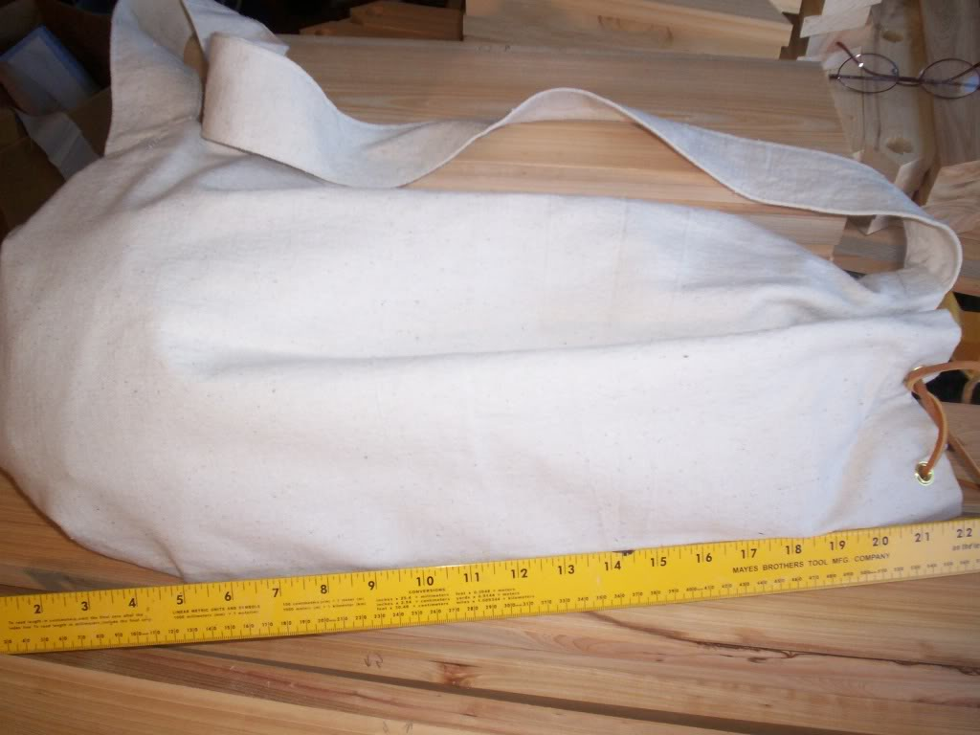
Another View
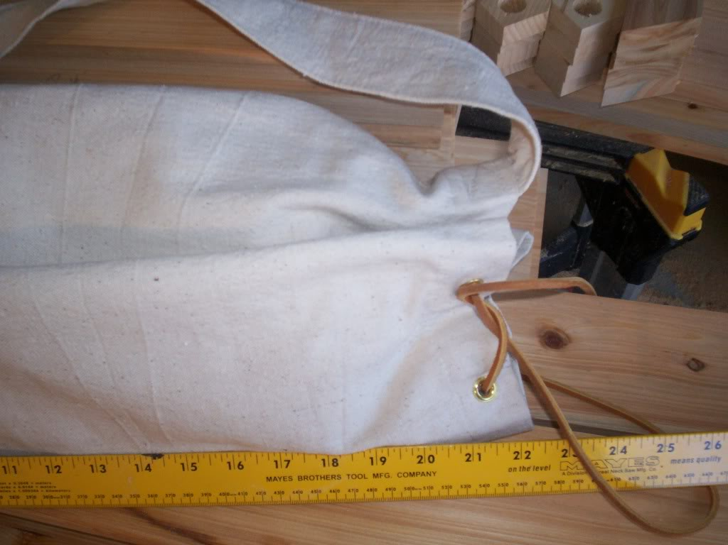

- Quote
- Edit
- Options

Sjöröveren
- Plunderer
- Member

- 457 posts
- Location:Minnesota, Land of 10,000 Lakes and 1 mini-ocean
- Interests:Re-enactment, gradually working my way back from the 19th Century. I figure I'm in about 1700 right now. I specialize in the history of medicine. I like maps, and the general history of geography and geodesy. <br />And in case you're wondering, "Sjöröveren" is Swedish for "the sea rover." And it's supposed to be spelled "Sjörövaren" but I guess it's too late for that!
(IP: 64.131.55.152) · ·
Posted April 3, 2009 · Report post
Foxe said:
Pat, given the similarities in shape I suspect that the classic "ditty bag" evolved from the snapsack. In fact, I'm not convinced there is enough difference between the two to even think of them as different items.
The overtly decorative knotwork that we see on later seamen's artifacts seems to have been a fashion which developed in the later 18th century and reached its heyday in the 19th. We do know that knots were used generally for decorative purposes during the GAoP, just apparently not in such complex forms or to such an extent as later. I'm sure that having some sort of well-dressed end to the drawstrings of a bag, and a turks' head woggle to pull them closed would be quite likely. (Since we don't have a period bag to compare this is obviously just speculation based on the use of knots elsewhere in the period).
This is just some idle speculation here, but I wonder if the rise of decorative knotwork was borne from longer sea voyages? The late 18th century and all of the 19th were the heydays of the great navies of the world, as well as years-long whaling expeditions. Could the long voyages have resulted in more idle time for the seamen, who spent that time doing knotwork, scrimshaw and the like? The coincidence is tempting.

- Quote
- Edit
- Options

LadyBrower
- Pyrate Captain
- Member

- 582 posts
- Gender:Female
- Location:Walden, NY
- Interests:Sewing, Crochet, Knitting, Reading, Cooking, Baking, Yoga, Kickboxing, Bellydance, Guitar Hero, Rockband
(IP: 69.206.131.239) · ·
Posted April 5, 2009 · Report post
I'm working on bags of all sorts for my piratical men (well, mostly for them to carry my stuff)... Now, is this "snapsack" similar to the modern military bag (that amazing green thing?) but much smaller? I was going to use that for my model and scale it down...

